15B17CI471 Algorithms &Problem Solving Lab
Lab Test – 1 Thursday 2:30 PM – 4:15 PM
Set - A
Given a string you need to print all possible strings that can be made by placing spaces (zero or one) in between them.
Input: str[] = "ABC"
Output: ABC
AB C
A BC
A B C
Set - B
Given a keypad as shown in the diagram, and an N digit number which is represented by array a[ ], the task is to list all words which are possible by pressing these numbers.
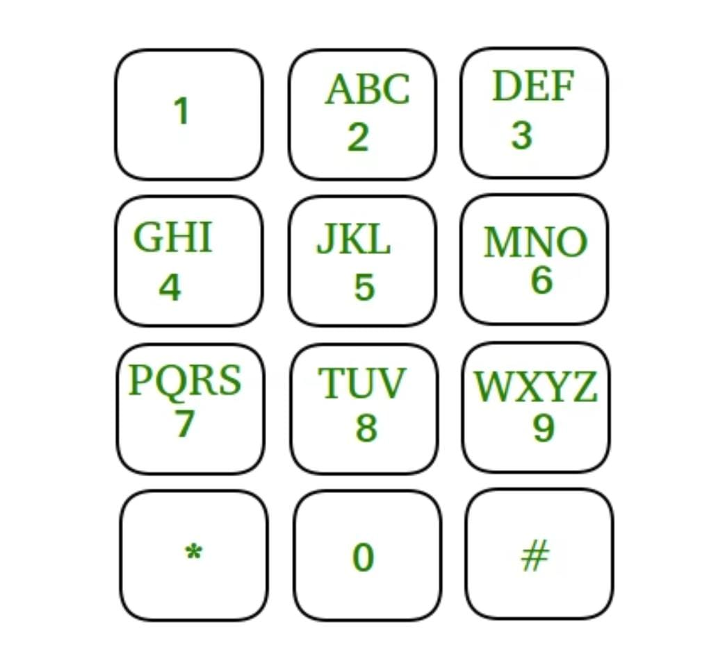
Example 1:
Input: N = 3, a[] = {2, 3, 4}
Output:
adg adh adi aeg aeh aei afg afh afi
bdg bdh bdi beg beh bei bfg bfh bfi
cdg cdh cdi ceg ceh cei cfg cfh cfi
Explanation: When we press 2,3,4 then
adg, adh, adi, ... cfi are the list of
possible words.
Example 2:
Input: N = 3, a[] = {3, 4, 5}
Output:
dgj dgk dgl dhj dhk dhl dij dik dil
egj egk egl ehj ehk ehl eij eik eil
fgj fgk fgl fhj fhk fhl fij fik fil
Explanation: When we press 3,4,5 then
dgj, dgk, dgl, ... fil are the list of
possible words.
Constraints:
1 ≤ N ≤ 10
2 ≤ a[i] ≤ 9

